Day 1 Day 2 Day 3 Day 4 Day 5 Day 6

Day 1
Question 1
Which substances react to form hydrogen gas?
- Calcium and water
- Silver and dilute hydrochloric acid
- Magnesium and steam
- Zinc and dilute hydrochloric acid

- 1, 3 and 4
- 1 and 3 only
- 2 and 4
- 4 only
Question 2
Three students, X, Y and Z, are told solid P reacts with dilute acids and also conducts electricity.
The table shows the students’ suggestions about the identity of P.
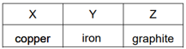
Which students are correct?
- X, Y and Z
- X only
- Y only
- Z only

Day 2
Question 1
The table shows some physical properties of four different substances.
Which row describes the properties of a non-metallic element?
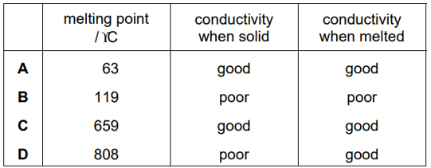
Question 2
The table shows the results of separately heating four metals with oxides of different metals.
The four metals are iron, copper, magnesium and Y.
The results are shown.
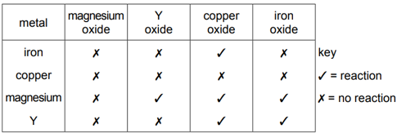
What is the order of reactivity of the metals, least reactive first?
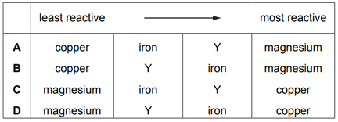

Day 3
Question 1
Some statements about the reactions of the metals tin, lithium and manganese are listed.
- Tin does not react with steam but does react with dilute hydrochloric acid.
- Lithium reacts with cold water.
- Manganese does not react with cold water but does react with steam.
What is the order of reactivity of the three metals?
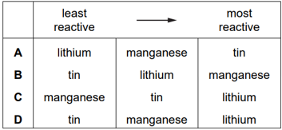
Question 2
Part of the reactivity series of metals is shown.
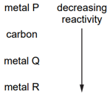
Which row shows hot each metal is extracted from its ore.
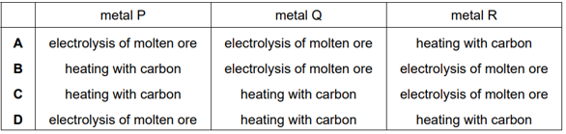

Day 4
Question 1
Metals W, X, Y and Z are reacted with dilute hydrochloric acid.
The oxides of metals W, X, Y and Z are heated with carbon.
The results are shown below.
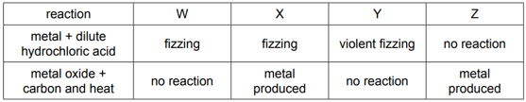
What is the order of reactivity of the metals?
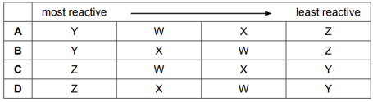
Question 2
Coke (carbon) and limestone are two raw materials used in the extraction of iron from hematite.
Which type of reaction occurs when each substance is heated during the process?
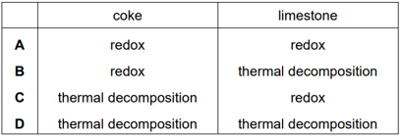

Day 5
Question 1
Four substances present in the blast furnace during iron extraction are listed.
- Calcium carbonate
- Carbon dioxide
- Carbon monoxide
- Iron(III) oxide
Which substances are both a reactant and a product during the reactions occurring in the blast furnace?
- 1 and 2
- 1 and 4
- 2 and 3
- 3 and 4
Question 2
Bauxite contains aluminium oxide.
Aluminium is extracted from aluminium oxide by electrolysis.
Which statement is a reason for why cryolite is added to the electrolytic cell used to extract aluminium?
- Cryolite decreases the rate at which aluminium ions are discharged.
- Cryolite lowers the melting point of the electrolyte mixture.
- Cryolite prevents the carbon anodes being burned away.
- Cryolite removes impurities from the bauxite.

Day 6
Question 1
The diagrams show what happens when three different metals are added to water.
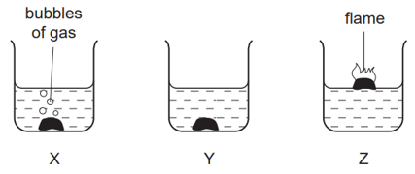
What are X, Y and Z?
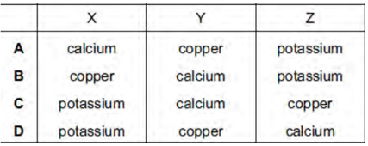
Question 2
A student carried our an experiment to find the order of reactivity of five metals.
They were tested with cold water, hot water and steam and the results recorded in a table.
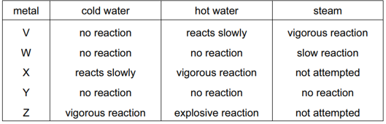
What is the order of reactivity of these metals?


